Programming Project Analysis

By Farhan Mirza

Programming Project Overview

For the programming project, the project will be a 2D shooter where a user controls a spaceship and must battle enemies that come in waves, with these waves becoming progressively harder with each passing one as the number of enemies increase in each wave and new types of more difficult enemies would be introduced after a certain number of waves. There were also be other hazards onscreen like meteors and big laser beams that the player would have to avoid. The user would move the spaceship up, down, left, or right to avoid enemy lasers or other hazards and they would shoot back at the enemies with their own weapons to destroy the enemies. The player will have a certain amount of health and will lose some when they get hit and if they lose all their health then the game ends. In addition, the game will have a scoring system based on the number of enemies that the play killed and the type of enemy that was defeated.

Problem Identification

There would be many instances to use computational methods when making this game. For example, decomposition would be useful to break down the game into the different players, enemies, and other hazards as I would be able to handle the player character separately from the meteors and both of those separately from the boss enemies. In addition, decomposition allows me to organise the code into subroutines which would let me call on parts of the code when they are needed in the game, such as the start-up screen when the player dies. Decomposition will also work well in the program because the project will use object-oriented programming in the game’s code so the player, enemy, weapons, and bosses are all in separate classes amongst other parts of the game and decomposition would make to easier for me to look at each of these classes individually which would make the task of writing the whole program easier to manage. Thinking ahead will be used when writing the code as doing that will let me identify the inputs and then consider what the appropriate output should be make sure that the output given does not break the game in some way. For example, in the program, the player can move up, down, left, and right but the game will need to use preconditions make sure that the player cannot move off the screen by making their x and y coordinate does not change if those coordinates are already too close to the edge of the screen. Also, when a player gets hit, they lose health, and the game would have to make sure that they do not keep losing health if it already and 0 and instead use a precondition to end the game. Preconditions would also be used when the game checks the that the length and width of the screen entered are big enough for the game to be playable in, as if they are too small the player will not be able to dodge enemy attacks as well as other hazards. Furthermore, thinking logically would be important when making the game as there are many varied factors that must be checked to determine an output by the program making a particular decision. In the program, the timing events for new enemies and hazards being introduced use if statements to check if a particular amount of time has passed before that new enemy is introduced and if that time has not passed yet, then the enemy will not be introduced. Also, the program must decide which direction the player should move in which depends on the key that they press and if statements in the player class are used check if a given key has been pressed and then provide the corresponding output. In the program, abstract thinking would also be used in order to let me only focus on the important parts of the program and ignore unnecessary and non-essential features of the game at least until the essential parts of the program have been finished. For example, the designs for the player, enemies and other hazards in the game would be either be simple designs that I made, or royalty-free images. The game’s development wouldn’t be focused on giving the characters complicated designs as that isn’t important to the game, it would instead focus on making the player and enemies visually distinctive through simple means like giving them different colours.

Stakeholders

The stakeholders of the game are a few of my school friends who will want to play the game. The main client is a friend of mine called Owain Moon who also does computer science for a-level. Owain wants me to make a 2D wave-based shooter where someone plays as a spaceship and must move around the screen to avoid enemy attacks whilst shooting back at the enemies to destroy them. He wants the game to be enjoyable and fair for the player and wants the game to become more difficult over time. The client’s game will do this by introducing new and harder enemies' overtime as well as more hazards, also in each new wave there will be an increased number of enemies for the player to fight against. New enemies will have new, more difficult attacks that the player will have to learn and must be balance all these different attacks will make the game become a lot harder over time. Having different enemies that do different attacks will also make the game more enjoyable because the player will not just face the same enemies repeatedly which would just become stale for them, instead they would fight a varied cast of enemies so the game would be more interesting. My client also wants other features in the game such as a scoreboard, a multiplayer mode, and a main menu that the user can interact with to do different things on. My school friends who want to play the game will want a game that is easy to learn and play, but difficult to get good at so that they would have to become skilled at the game to do better at it. The controls will be added to the main menu so that people know how to move the spaceship and use its weapons and there will also be a tutorial accessible through the main menu where the player can learn how to use the controls against enemies and where they can be introduced to the distinct types of enemies and their abilities. This will allow them to learn how to play and how to counteract enemies individually, however when they play the actual game they will have to deal with multiple enemies and hazards at once which will be quite challenging so they game will be easy to learn but hard to master. Another stakeholder will be the artist (or artists) whose artwork is used for the sprites of the player, enemies, hazards, the background, and other areas of the game. This is because their work will be featured across the entire game which will publicise their work. They will also get credit for their work in the game which would make more people discover that artist and this would cause the artist to gain more recognition so others may want to hire them to make art for something they want to do (like a game or video) which would cause them to make money. Furthermore, the art would make the game more visually appealing to the other stakeholders and my client would want to game to look as nice as possible so by using other people's artwork with permission the game can look nicer for the other players when they play the game. Parents could be another stakeholder for the game as many of them might want a game that their children can enjoy whilst at home and that their kids will be playing for quite a while. The fact that the game becomes more difficult over time will make the children spend longer playing it as they will want to become better at the game to get further into it and see new enemies and hazards. Seeing how long they can survive before dying would become the goal of the game for those children and longer they spent playing the better they would become at it. This would give the game more longevity so the game would be a game that parents know their kids will spend a lot of time playing.

Interview with the Client

1. **Do you have any ideas for different types of enemies?**

“You could have larger enemies which stay on the left end of the screen which fire at you from there and also lasers which move across the screen for a short amount of time.”

1. **Are sound effects important for your game, if so, why?**

“They are fairly important because they make the game more engaging and immerse the player, as it makes the world feel more believable. However, they are not a necessity.”

1. **What are some key features of the start-up screen of the game?**

“The start-up screen should include a start button, settings to change things about the game, a way to view high scores, and a way to show controls.”

1. **What should the changes be in different difficulty settings?**

“On higher difficulty settings, the player should lose more health, deal less damage to enemies and more enemies will be able to appear onscreen at once in a given wave.”

1. **How often do you play video games?**

“Quite often, about 6-8 hours a day since the lockdown started.”

1. **What kind of power ups should the game have?**

“There should be different power ups for increased attack, increased health, increased speed, a shield to defend attacks for a particular direction and one for an increased rate of fire.”

1. **What sort of music would fit this game?**

“Some sort of 8-bit action music would suit this game quite well as it fits in well with the design of the overall game.”

1. **Should the game have a certain logo, and if so what kind?**

“The logo should be related to spaceships in some way and the logo itself should be comically over-the-top.”

1. **What should a boss design in the game include?**

“The boss should have certain weak points that must be destroyed for the to defeat the enemy and boss should use lasers that lock onto the player position for a short period of time before firing after giving off a warning.”

1. **What obstacles could there be onscreen other than enemies?**

“There could be spikes that periodically move up and down the screen that can damage the player if they collide with them. There could also be special kamikaze ships which try to crash into the player and will explode after a certain amount of time.”

1. **Are there any other features you want in the game?**

“The background could change overtime show how far you’ve progressed, and the different enemies could have different sounds for their lasers.”

1. **Why do you want this game to be made?**

“I would like the game to play with and have fun, and with the multiplayer mode I'd be able to play with friends during a pandemic when I can’t meet them in person.”

1. **What would the benefits of making this game be and why?**

“You would be able to play with friends, give something to pass the time with, can't always meet friends in person so you can still keep in contact with friends and have fun with them.”

1. **What is the most important feature of this game?**

“The fast-paced gameplay and progressive difficulty which keeps the game challenging and engaging even when players has gotten better at the game.”

1. **Who would want to play or own this game?**

“Children and teens because of the relatively simple engaging gameplay and parents might want it to provide a distraction for their children.”

1. **How should the player progress through different levels?**

“Every time you defeat a boss, you progress to the next phase. This allows for good difficulty curve.”

1. **How should the levels be different from each-other?**

“When you progress to the next phase, the music and background shall change. And the enemies and boss fight will be harder.”

Research

For this project I have done research into games with similar mechanics and a similar genre to see how those games incorporated similar features to the ones I want into their videogames. These features are discussed in further detail in the next section, but they include:

* Making the game become harder overtime by introducing harder enemies and hazards and more of them.
* Using a scoring system that based on the number and type of enemies that you have killed.
* Including instructions on how to play the game and other key features on the main menu.
* Including a health system that makes you lose health when you hit any given hazard.
* Having a movement system that allows players to avoid incoming enemy attacks.

**Downwell**

In this game, the player travels downwards and shoots below them at the enemies trying to attack them with ammo that refills overtime. The player can land on platforms beneath them and collects jewels which act as points in game and at the end of each level they get to choose an upgrade. The enemies become harder overtime in Downwell as they move faster and lock onto the player to an extent. This could be incorporated into the game with the lasers of later enemies moving faster and tracking the player to an extent to make the game harder overtime so that the player feel a sense of progression as they play and so they understand that the longer they last, the better at the game they are. The game might also add another way of getting points through items you can collect onscreen like the jewels in Downwell, these items would fall from the sky like the meteors so that the player would have to do some careful manoeuvring to avoid getting hit by the meteors or other hazards. This would mean that the player would need some skill to get the points so they would be encouraged to improve at the game to be able to get the extra points. In Downwell, the player also finds powerups when they go into the certain rooms and some of these powerups might be added to the game, such as the one that lets the player shoot 3 bullets instead of one for a certain amount of time as that would reward the player for surviving for a certain amount of time. Moreover, there might be a similar upgrade system in the game except the player get to choose between three upgrades if they survive for a certain amount of time and this would be added because it allows the player to become more powerful overtime which lets them handle the tougher enemies when they get further into the game. Each of these upgrade sections would occur after a boss fight as that is a natural conclusion to a phase of the game.

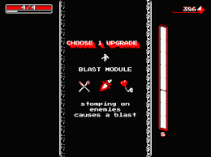

Features that could be included:

* Using enemies that attack faster and have more lock-on as the game progresses.
* Upgrade the player after they beat a boss fight before continuing.
* Include upgrades that can be found in-game through combat.

**Cuphead**

Cuphead includes some bosses that are fought in a comparable way to how they are in the game, with the player controlling an aeroplane that is constantly shooting at the boss whilst simultaneously having to avoid the boss's attacks by moving up, down, left, or right. The bosses also have several separate phases and once the player has dealt enough damage the boss will move onto its next phase which has different attacks from the previous one. In addition, the attack that the boss chooses within a phase is random, so the player will not know which attack is coming next in any given phase, they only know about which attacks are in each phase. The idea of bosses having multiple phases is something I will incorporate into the boss fights so when a boss loses a certain amount of health, it will switch to more difficult attacks against the player instead. This will make the boss fights in the game more interesting as there are distinct stages to each boss fights, all of which are different from each-other. This means that the player will have to learn many different attacks and learn which ones are in which phase. I should also give the bosses a health bar so the player knows how much health the boss has left and when their next phase will begin. The randomised attacks that Cuphead uses should also be incorporated into the game because it means that the player will not just be able to rely on memorising a pattern to get past bosses but will instead have to learn how to dodge the boss's different attacks. Furthermore, in Cuphead, the little aeroplane you control in these boss fights has different methods of attack as it can either fire bullets that move horizontally to towards the other end of the screen, or they can shoot bombs which will arc downwards in front of the player. The game could similarly have multiple ways to attack enemies with different attacks moving across the screen in unique ways and maybe dealing varying amounts of damage. Having multiple different weapons allows a player to become more skilled at the game as they will have to figure out which weapon is best used at which moment and being able to do that quickly will allow them to deal more damage to any given enemies.

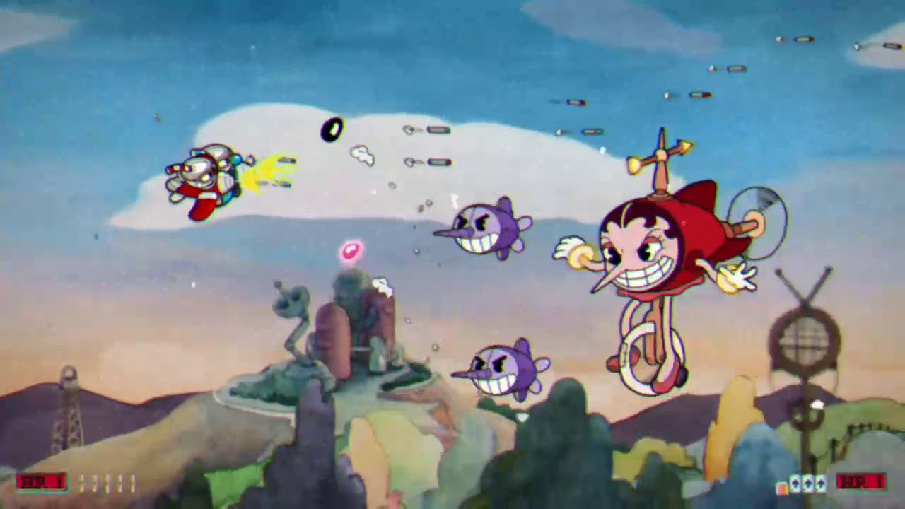

Features that could be included:

* Multiple stages to each boss fights- with each stage introducing new attacks.
* Giving the player different weapons which are more and less useful in different circumstances.
* Using randomised attacks for bosses so that they are less predictable.

**Undertale**

The movement system of Undertale consists of the player controlling a heart which represents them and moving the heart up, down, left, and right to avoid incoming enemy attacks. The player does not attack the enemies whilst dodging attacks, but certain bosses will change the movement system in certain ways to make the gameplay more interesting. One of the bosses makes the heart completely immobile and gives the player a shield to block attacks coming in from either the top, bottom, left or right. There could be a similar shield powerup in the videogame which the player could use to defend themselves against telegraphed, fast lasers moving in from one of those directions, or this could even be a phase of a boss fight, with the player's spaceship being immobilised whilst having to defend against attacks using a shield instead. Having a phase like this could make the gameplay more varied and interesting for some players as there is an entirely new form of gameplay. This would help players to not get bored whilst playing due to the greater variety. 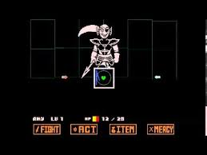

In another boss fight, the player is shooting upwards back at enemies and other hazards onscreen during a boss's attack (but they are not damaging the boss themself) and when the player shoots the bombs onscreen, they explode and quickly fire a vertical laser so the player must move left or right after shooting a bomb to avoid losing health. In the game, enemy bombs could work in a comparable way except the laser fired would move horizontally instead and these bombs would be used as they would force the player to be more mobile when player the game as they know that they cannot just wait in the same top when a bomb approaches otherwise they will take damage. This increased use of mobility will make them better at the game so that they last longer and get a higher score as well.

Features that could be included:

* Changing the movement system for specific boss fights.
* Using hazards that you must move out of the way of after shooting to avoid taking damage.

**Super Mario 63**

[**https://www.newgrounds.com/portal/view/498969**](https://www.newgrounds.com/portal/view/498969)

The start-up screen of Super Mario 63 includes the ability to enter the settings for the game, start the game and access extra options depending on the box that is clicked. Each of the different sections of the start-up screen are in a different colour and when the goes over one of the options with a mouse its box will get bigger to indicate that you can click on it. There will be similar choices on the game's start-up screen but there will be options to view controls or instructions for the game and a box which you can click on to view the high score. Differentiating the boxes by colour (as well as naming them) makes it obvious to a player that which box lets you access what on the start screen. When a player goes over a particular box, it will change to a lighter shade of the colour of the box so that the player knows they can click on that box to access that option. This will remove confusion from the start-up screen for the player so that it is easy for them to navigate.

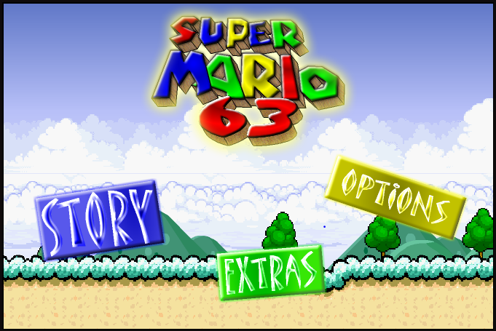

Super Mario 63 also has a tutorial area where the player can test out the controls in a safer environment than the rest of the game and see what some of the enemies and powerups are. The game should have a similar tutorial level as player should be allowed to get to grips with the controls before they begin playing the game. If this did not happen and players were thrown into the main game with no practice, then they would not enjoy the game very much as they would not understand how to play and would just keep dying instead.

Features that could be included:

* A tutorial area where the player can try out their different moves and attacks.
* Icons and boxes on the menu that change colour when you hover over them.
* Being able to look at the controls for the game from the main menu.

Essential Features

1. The player would be able to move around in all directions and shoot at enemies as well. This would allow players to manoeuvre around the enemy lasers and fight back to progress the game into its next stage and to allow the game to be playable at all.
2. The game will become progressively harder overtime. This would entail having new waves introduce new enemies and obstacles such as stronger enemies, meteors and boss enemies appearing after a certain amount of time. The number of enemies that appear each wave would also increase by a given amount after each consecutive wave. Having each wave become progressively harder is important because it gives a sense of progression to the game itself and allows players to know if they are getting better at the game as the longer, they last the better they are. They can also compare their results with their friends and then compete with those friends to see who can last longer at the game.
3. The game will have a scoring system. Every time a player kills an enemy, they will get a point and stronger enemies and bosses will be worth more points as they are harder to defeat. When the player dies their score will then be saved to a file and top five scores will be displayed in a section accessible from the main menu. Scoring is important because it allows people to better compare how good they are at the game and gives them a goal to work towards as people will want to make it onto the top five scores list and even become the player with the highest score and this will encourage them to become better at the game.
4. There will be a health bar for the player, and it would be on the screen underneath the player character. Whenever the player collides with an enemy, laser, meteor, or any other hazard, they would lose some health and the amount lost would depend on what they collided with. When the player’s health reaches zero then the game would be over, and the player would be taken back to the main menu. The use of health and a health bar means that there is a consequence for the player getting hit which makes the game more enjoyable as the player knows that if they get hit too much then they will lose the game. This encourages them to get better at the game, so they do not get hit as often, last longer and get a higher score.
5. A set of instructions would tell the user how the control the character, which would entail moving them around, shooting the enemy and their speed boost ability amongst other things and they would also tell the player about enemies, meteors and powerups and what each of those things can do. Having the instructions means that users will understand the basics of the game before they begin playing, because if it did not have a set of instructions then it would be difficult to play the game as the user would not know its controls or the different hazards that can appear onscreen. This would likely make the game unfun for many players as they would not understand what to do and would just keep dying instead, which would make them frustrated and make them stop playing the game.
6. The aforementioned powerups would have certain percentage chance of being dropped from meteors when the player shoots at them. They would then slowly fall to the ground and the player would have to catch them before then go offscreen. The powerups would include health boosts, ammo boosts and speed boosts and the powerups would be important for the game because they let players survive for longer and help make the game more interesting as the player will now be able to boost themselves throughout the game and become more powerful overtime. It also gives player an incentive to shoot the meteors rather than just letting them collide with the enemy ships.

Limitations

1. Time is the biggest limitation as I must balance writing the program with the work from my other subjects as well as homework and because we have not been in school for several months, there will be a lot of work and topics that we will have to catch up on. This means that I will have less time to code the game than there would be ideally so the final product might end up being made without the all the non-functional requirements. In particular, it will be difficult to include online play with my time constraints.
2. Consistent feedback from my client about what is being adding to the program at a given moment will not be possible as my client does not go to this school. In addition, the client and the other stakeholders will also have other priorities like their own subjects that they’ll need to focus on which leaves even less time for communicate with me. This means that the program that is created won’t be fully accurate to the vision of the client so the game itself will be shaped less by the client than I would like.
3. There is a lack of image and sound resources that can be used to make the game. The resources in the game would have to be royalty-free, as I wouldn’t want to pay for better images or premium sound clips, and I am not a particularly good artist either. Finding royalty-free images for players, lasers, meteors, a background and enemies amongst other things and royalty-free sounds for collisions, explosions and other things will take time that could have instead been used for coding or designing. All of this means that there will be less time for other more important aspects of the code and the programming project which will limit how good the game can be. The royalty-free images also may look less than better images that could be bought instead, so the game might be less visually appealing to some users.
4. There aren’t as many free resources for learning different pygame commands as there is for regular Python which means that if I don’t know how to do something in pygame, then it is less likely that there is a solution online. This lack of learning resources for pygame would mean that it won't be possible to code in some features that I’d want in the program as I wouldn’t be able to find out how to code them online, which limits how complex my game can be.
5. How well the user can play videogames might be a limitation because if they haven’t played many videogames then it will be harder for them to understand how to control the character. If they don’t play games or haven’t used a controller then they might misplace their fingers on the wrong keys or buttons causing them to fail due to a lack of experience. This is a problem as it might cause some newcomers to enjoy the game less as they struggle to play it, however the game won’t be hard to control, and the controls will be able to be seen from the main menu which should alleviate this to an extent.
6. The quality of the product visually might not be very high because the game will most likely use royalty-free images for characters and enemies as mentioned before. But there also won’t be things like complex explosion animations or animations for hovering over icons and other things because I don’t have the skill to animate that, and the alternative would be to spend a bit of money for someone else to animate which isn’t ideal either. This means that the game won’t look as impressive as it potentially could which might cause some people to be dissuaded from playing it.
7. My idea for the programming project isn’t exceptionally large in scale as it is simply just a 2D wave-based shooter that gets progressively harder overtime. Whilst there are other aspects to the game like a leaderboard, playing co-op and possible online play, the game is limited to the constraints of what can be done in a 2D shooter. This means that the game might start to get repetitive after a while because the basic actions the user does almost always stay constant. This will also cause a lack of complexity in the game and its code since similar ideas might be used in different phases for new enemies and bosses. All of this may lead to a game that is less impressive from a creativity and design standpoint as well as not being as fun to play as it could be due to the repetitive nature.
8. The player will only be able to move up, down, left, and right and the player speeds will be constant. The spaceship won’t be able to do something like dynamically follow the position of the mouse either so movement options will be limited. This could make the game less fun to play since the user won’t be able to do a lot in terms of moving out of the way of attacks and these limited movement options might even cause them to take damage sometimes when they should not have.
9. When the player dies in game, they must go through the whole game again to get back to the point they were at before. This means that if a player kept dying to a certain boss, then they would have to play through all the content before that boss again to fight them again. This may discourage some players from playing the game because they don’t want to put in the effort needed to beat some of the bosses or they might get bored of repeating the same content repeatedly when they just want to fight the boss.
10. Pygame only lets a programmer use eight different timed events which repeat after a certain number of ticks at any given time. This will limit the number of different unique enemies and hazards that can be on screen during a single phase. I will reset the timed events after each boss, but this means that only eight different attacks can be repeated in different waves between any two phases. This means that the threats the player faces in each wave might not be as varied as it would be ideally, which makes the game less interesting.

Hardware and Software Requirements

1. **Needs Pygame and Python to run the game-** The code is written in Python and uses large parts of the Pygame library, so their latest versions need to be installed for the game to run.
2. **Needs Windows or Mac OS to run the game-** These are the platforms that should always have the latest version of Python.
3. **The game will run on a computer or laptop-** This is since the version of Python that I am using runs on a desktop, not on devices like phones or tablets.
4. **A keyboard or controller and a mouse will be needed-** The keyboard and controller are the devices that I will be mapping controls too. The mouse is used to navigate menus when the game starts and ends.
5. **The player’s screen must have a length and width in pixels enough to fit the player, enemies, bosses, and other hazards onscreen-** This is so the player can navigate around enemy attacks and other hazards without the game screen being too big to fit on the monitor’s screen.
6. **The user will need a stable internet connection if the game has online play.**
7. **The minimum specifications of the game should be very low-** This is because the game probably won’t use much processing power and it will simple PNG images are used for the graphics of the characters, weapons and environments. Therefore, the integrated graphics of a CPU should be enough to run the game.

Success Criteria

Functional Game Requirements:

1. **Use a health system in the game that makes the player lose health when they collide with hazards-** This will add consequences for failing to dodge attacks and will make them want to improve at the game by not taking as much damage so adding health would make the game more enjoyable because it would the player want to try and master the game.
2. **Make the game playable with another player-** This will let two people play with each-other at the same time so they can work together and survive for longer. Games are usually more enjoyable when people play them with others as both players can compete against each-other to see who can last the longest and who can get the highest.
3. **The game will also need to fit two sets of controls on one keyboard-** This needs to be done in a way where the keys for each player are far apart from each-other so their hand won’t bump into each-other or overlap whilst playing which would make it harder to press the keys.
4. **Introduce multiple different enemy types, including bosses, overtime as the game progresses-** Newer enemies will be introduced the longer the player survives because it will make the game become harder overtime which will make surviving for longer feel more satisfying for the player as they would know that the enemies get harder overtime. It also helps to keep the game feeling fresh and unique as the player won’t just be fighting the same enemy each wave.
5. **Use a scoring system for the enemies destroyed and record the score and time the player survived for-** The scoring system will show the user how well they have done in a particular attempt at the game which gives them something to compare to when they play the game again. The player will want to beat their previous score so they will play and enjoy the game more. Recording the time that the player survived for gives a similar goal as the player will want to survive for longer in consecutive attempts.
6. **Have an interactive User Interface that lets players start a game, check the high scores and check the controls-** All the sections that the UI includes are very important to start the game lets the user play it in either single player or co-op mode. Checking the high scores is also important as it gives a player a goal to work towards as they now have a set of scores that they will want to beat and checking the controls is necessary so that the user know how to play the game.
7. **Have a consistent design and layout-** Things like the font will always stay the game and the main menu of the game will look neat and presentable so that it is more visually appealing to someone playing the game. A simple layout will also make the game menus easily navigable, so the user doesn’t get frustrated.
8. **Allow the user to choose the height and width of the screen-** People will play this game on computers or laptops that have monitors of many different sizes, so the game must allow for different heights and width so that it can fit onto smaller monitors. This also means that the positioning of enemies and other hazards must change depending on the width and height so that they appear onscreen when needed.
9. **Include powerups (like extra health and ammo) in the game-** These will make the game more interesting as when they are introduced there will now be more factors to consider when playing the game.There might also be fake powerups in the game (that have a different colour to regular powerups) to trick the player and if the player catches them then they will lose health or ammo instead which will make the player cautious and more observant before going for a powerup.

Non-functional requirements:

1. **Allow a user to play with another player online-** Using online play would mean that two people can play the game together even if they aren’t using the same computer which will make it a lot easier for people to play together since they might not always be able to meet up at the same computer to play the game.
2. **Enable controller support for the game-** Some people will prefer to use a controller over a keyboard to play the game as that is what they play most games with. Also, if two people are playing locally then might be easier to play if one or both players use a controller, instead of having to share a keyboard.
3. **Include sound effects for lasers, collisions, getting powerups etc.-** Having sound effects will give additional confirmation of an event happening in the game and it also makes the player more immersed in the game because the sound effects make it more believable for them. However, I would have to make sure the sound effects I use are royalty-free.
4. **Have the background of the game change overtime-** The longer the player lasts, the more the background would change, and it would change significantly during boss fights. The change in background would give the players a sense of progression as they played the game as they would be constantly aware that they were progressing in the game.
5. **Have an AI player that can fight alongside the player-** If the user doesn’t have anyone, they can play with at that moment would still want to play co-op then they can play with an AI partner instead. This will allow them to have a co-op experience without having a friend to play it with.